Questions to Ask Donors/Funders

Asking the right questions to understand what your donors/funders really look for when making charitable contributions will help you position your nonprofit to receive more funding and stability in sustaining your organization. In asking donors/funders the below questions, the real purpose is to find out how they make the decision to give to an organization.

Here are some questions to get you started:

- What inspires your passion, and why?
- How do you decide which nonprofit organizations to support?
- To make a big contribution, what would you need to learn or see from a nonprofit?
- What evidence would a charity need to present to you after your donation has been made to ensure that your money was well spent?
- What comes to mind first when choosing a charity?
- Have you ever chosen to withhold your support from a charity or opted not to invest in it? Why did that happen?
- What did you like best about other charities that you have or are presently supporting? Why is it important to you?
- What about charities that, aside from their aim or cause, left you unimpressed or in which you would be hesitant to donate to? What were you attempting to avoid, and why were they a letdown?

Remember, most larger funders support other nonprofit organizations. Be extremely diplomatic and thoughtful when asking these questions.

Matrix for Funding Source Planning

 | Money Expected | % of Probability  (i.e., 50%) | Amount used for budget  (i.e., % of probability divided by money expected)
Example | $1000 | 50% | $500
Individuals
Memberships
Direct mail campaign
Events
Cultivating major donors
Planned giving
Volunteer opportunities
Board all gives
Other:
Other:

Foundations
Large/National Foundations
Regional Foundations
Family and community foundations
Corporate-based foundations
Donor Advised Funds
Other:

Corporate/Business
Corporate giving (grants) programs
In-kind gifts programs
Sponsorships
Retail
Other:
Other:

Government
Federal Grants
State Grants
Sponsorships
Local Grants
Contracts

Other/Miscellaneous
Earned income (specify)
Religious institutions
United Way & other federated
Kiwanis, Lions, Professional groups
Labor Unions
Other:
Other:
Other:

Sample Board Member Commitment Form

Name _______________________________________
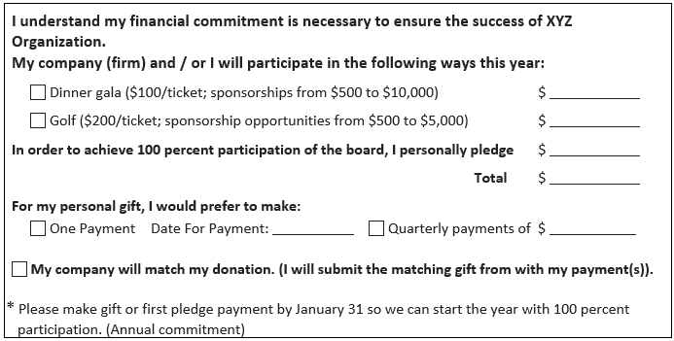
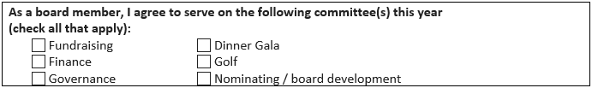
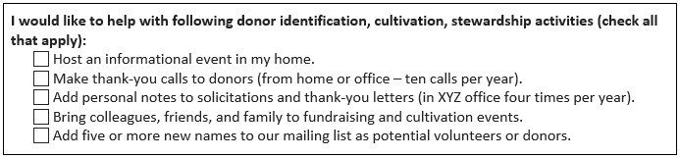
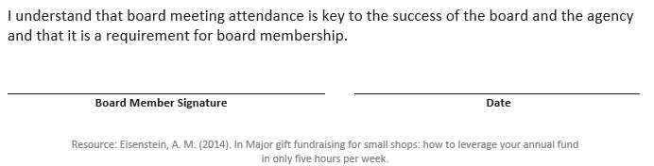

Finding Donors: The 3 Circle Exercise

To start finding donors, think of your organization as a bullseye on a dart board and focus on the first 3 circles for best results.

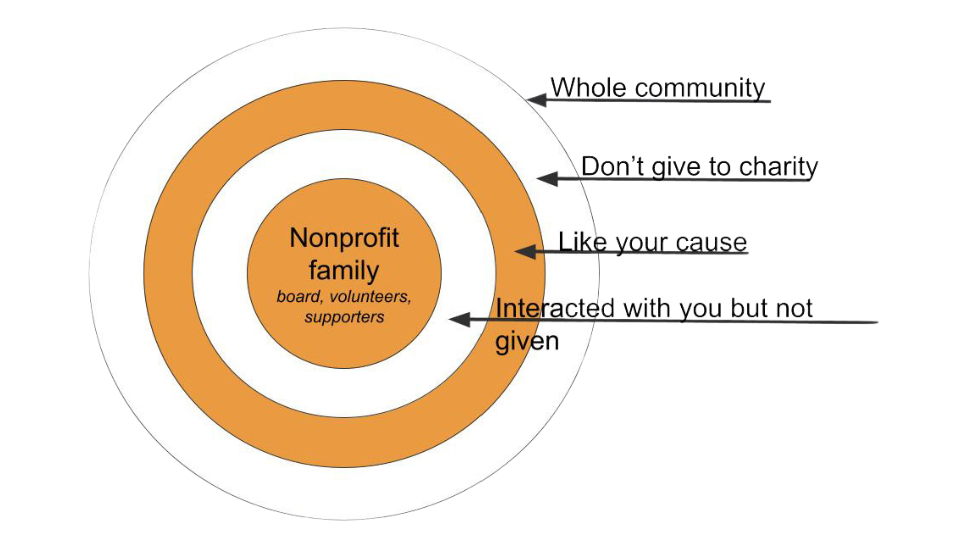

1. Start in the middle circle, which is made up of your nonprofit’s family:

- you
- your Board
- your volunteers
- your current supporters
- These people are already invested in your mission and care the most about your work.

2. Go one circle out. Here’s where you find people who have interacted with your nonprofit – or have a connection to your nonprofit and haven’t not had the opportunity to give.

- friends of Board members and volunteers
- people who have attended events but haven’t become donors
- followers on social media who haven’t yet given
- people who have shopped in your thrift store, vendors, and anyone else who has had an experience with your nonprofit but hasn’t yet made a donation

Maybe they haven’t given because they haven’t been asked.

Or maybe they don’t see the connection between their donation and making a difference in your organization’s mission.

Use your Data, outcomes and measurements, to make a compelling Ask that motivates people to give.

This ring on the bullseye is full of people who are already giving or will give when “Asked!

3. Go one more circle out. The next circle out is where you’ll find people who care about your cause but don’t know about your nonprofit yet.

For example, they care about the issue of hunger, but don’t know anything about your food pantry.

Finding these people is actually easier than you might think once you have your Ideal Donor Profile nailed down.

Excerpt from The BEST Way to Find New Donors for Your Nonprofit, Get Fully Funded

Mapping a World of Funding Opportunities

Mapping The Known Universe

- Gather your Fund Development Team and Board Members
- Supplies:
  - Room with large whiteboard or chalkboard
  - Supply of different color markers
- Procedure:
  - Place your organization at the center of the map
  - First, identify where your funding has been coming from
    - Start with broad areas, then move out to specifics
  - Next, brainstorm new ideas
    - All ideas are listed – no editing yet!
  - Finally, prioritize which efforts will have the best payoff

The map that you will create will end up looking something like this:

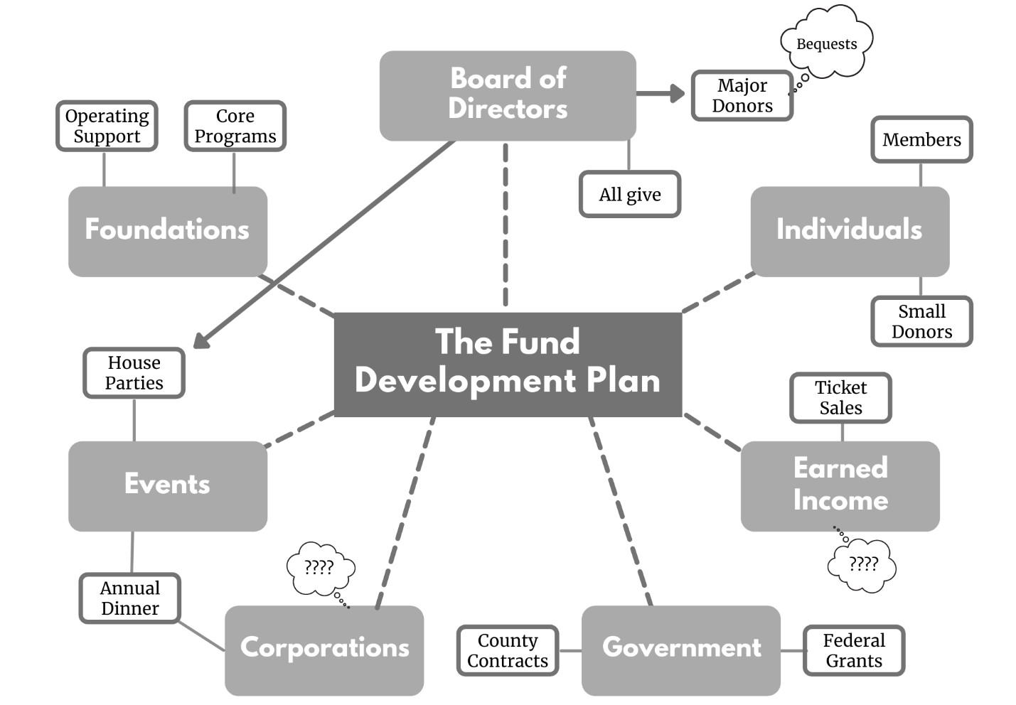

Expanding The Known Universe

- After you’ve put together your Fund Map, this is the next step with everyone.
- Supplies:
  - Flip chart paper
  - Post-it notes
  - Different color markers
- Procedure:
  - Create a flip chart paper for each major bucket from your Fund Map (Corporations, Individuals, etc)
  - Give each board member a stack of Post-it notes and a marker
  - Have everyone brainstorm connections or ideas they have that fall into each bucket
    - Write those ideas individually on post-it notes
    - Add to the flip chart paper for each bucket
    - Note: Make sure the person with the connection writes their name somewhere on the post-it note so you can follow up with them!
  - Review all Post-it notes, noting the connections/ideas everyone has. Have people reach out to their connections to grow your funding!

The boards that you will create will end up looking something like this:

